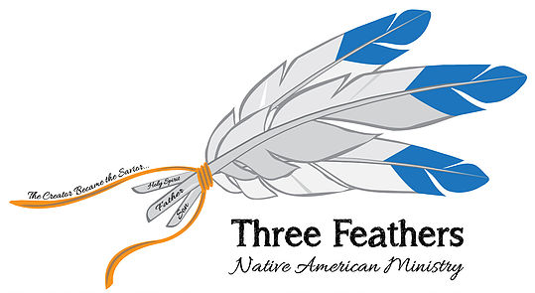

It was a giant step of faith to prepare for a 2,000 mile trip to Bemidji, Minnesota in July.
Praying for guidance the Lord laid the challenge before me – Could this be the beginning of
this new ministry?

With the help of friends and family promotional material was put together
for display – and a call went out for funds to pay for Native American
Bibles to be given to those who had none.
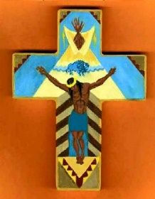
On the way North, I visited the Lumbee and Cherokee reservations in North and South Carolina making contact with their leaders. These contacts hopefully will result in speaking and teaching engagements in their churches and youth camps.
St. Louis, Missouri was the next stop where I presented this ministry to the members of the Fellowship Church. Rev. and Mrs. Chris Lybarger graciously invited me to spend the night
before moving on to Bemidji. This dear Pastor filled my gas tank. God’s provision!

The Bemidji Christian Missionary Alliance Church, was the host for the large group of Native American Indian pastors and friends. Huron Claus, Director of Chief Ministries, headquartered in Phoenix, Arizona was the convention coordinator. Belonging to the Mohawk tribe he is a man dedicated to reach his people. Huron Claus is a 3rd generation missionary. His parents and grandparents are well known all over the States for their work among the American Indian.

500 American Indian New Testaments were given to those who had none.
The Bible that you and I carry is not acceptable to the American Indian – it
is referred to as “The White Man’s Bible”. This translation’s cover has
Indian Art and the words “New Life” and is readily received by the tribes.

Did you know that there are 6,600,000 registered American Indians in the United States? Do you know that there are only 8% of them who are Christians. That’s 528,000 out of 6,600,000.
Our work is cut out for us and meeting with those who have the same calling is challenging and encouraging.
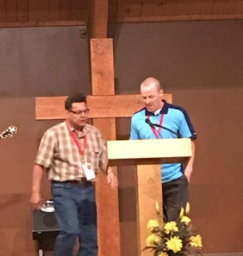
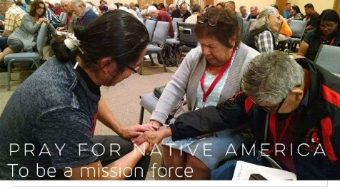

The financial needs for the travel and literature were monumental! We dared to believe God for the supply. Being retired from the pastoral ministry and living on a fixed income meant that dependence upon the Lord for this need was IT!

When the accounting for this journey was made – ALL of the costs were covered and we had
$3.41 left over! PTL! He never fails!

This is not an easy road. This is a battle for the souls of men, women and children. If these dear ones are not connected with the gambling tribes they are in deep poverty for their daily needs. BUT more importantly they are often left in poverty of heart and soul.

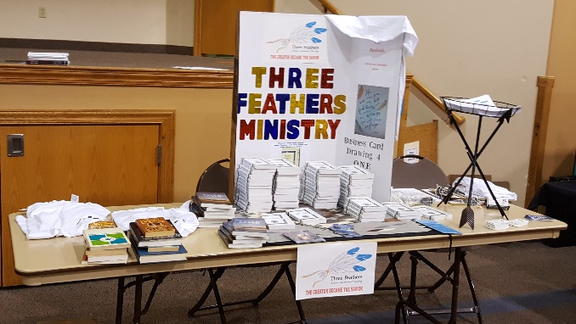

We contribute time and money to “foreign missions”. We give our old clothing to Goodwill.
As someone said to me recently – “The thought of the Native American Indian never crosses my mind.” Oh! what a shame!

I’m asking you – please put Three Feathers Ministry on your daily prayer list. Pray that the contacts made will result in opportunities to teach and preach to these forgotten ones who need a Savior. Pray that God will continue to supply the need for travel expenses, teaching aids and promotional material.

“My God will meet all your needs according to his glorious riches
in Christ Jesus. To our God and Father be glory forever and ever.
Amen!” Philippians 4:19 (NIV)

In His Service,

Robert De Corah
Three Feathers Ministry

Website: www.threfeathersministry.com
Address: Chapel Ministries
Three Feathers Ministry
478 South Greenway Drive
Port Orange, Florida 321237
E-Mail Address: robert@threefeathersministry.com

