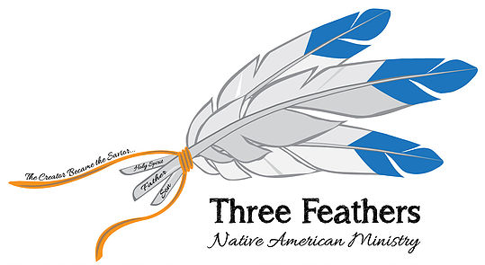

www.threefeathersministry.com robertdecorah@gmail.com Rev. Robert De Corah

Fall 2019

Dear Prayer Partners,

Thank you so much for praying for Pam and me as we spent 49 days traveling to seventeen reservations. I will try to highlight our journey to give you a sense of the challenges we faced as well as the successes.

We knew from the onset of our trip we had to be at three locations at certain times. The first was Cherokee NC where I preached at Cherokee Baptist Church and was able to share Native Ministries International with the congregation. The second was Indian Falls Creek Family Camp in Davis, OK. We spent a week attending the camp and passed out over 1500 brochures on our ministry. There were 2600 natives there including over 100 native pastors, most who received our ministry information to share with their churches. The resource and helps sections of the website will provide pastors and their people information needed to deal with many of the issues facing native people. Our third event was the Dakota First Nations Evangelism Conference in Pierre SD where, once again, I shared the website with Native Pastors from North and South Dakota.

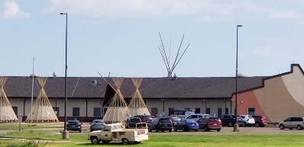
So, from Cherokee NC to Pierre SD, these are the reservations/tribes that we visited. Cherokee NC, Citizen Band of Potowatomi OK, Navajo AZ, Hopi AZ, Kaibab Band of Paiute AZ, Cedar Band of Paiute UT, Cedar Office of Five Bands of Paiute Nations UT, Little Shell Tribe of Chippewa MT, Blackfeet MT, Rocky Boys Reservation of Chippewa & Cree MT, Ft. Belknap Reservation of Assiniboine (my mother’s reservation) MT, Crow MT, Northern Cheyenne MT, Pine Ridge Reservation of Lakota Oglala Sioux SD, Rosebud Reservation of Lakota Sioux SD, Cheyenne River Sioux SD, Lower Brule Sioux SD, and Crow Creek Reservation SD.

I was able to share with each tribal office the benefits of using the tribal portion of Native Ministries International website. Every tribal office was so impressed with the amount of information now at their fingertips, they all said they will begin using it right away. Our prayer is that as they use the site, they will click on the other links that provide helps for problems facing natives; addictions, drugs, alcohol, suicide, breakdown of the family, etc. These links have a vast amount of Christian resources.

We attended the Crow Fair (pow-wow) in Montana for a couple days and spoke with many natives about the resources available to them on the website. I was well received there.

A big challenge we faced was finding native churches and, if we did find a native church, there was no information on contacting the pastor. Due to the change in the North American Mission Board strategy of only using funds to reach cities of 100,000 or more, the vast majority of funding was cut off from Native American Mission work. Thus most of the money for missionaries vanished as well as many of the pastors. My ministry is to not only provide resources to the native pastor and his church but to come along side that pastor to provide encouragement, and to share his work and needs of his people on the site. This trip taught us that going to planned meetings of native pastors, like the camp and conference, is the most cost effective way to meet pastors and get their churches signed up and share the benefits of the website.

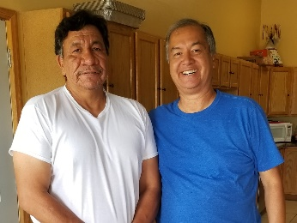
There are so many hurting native pastors and churches. One pastor said the average native pastor in his state gets paid $250 a month. He said he can’t pay his utility bill. One reservation has a suicide epidemic happening as write this. They have 6-8 suicide attempts every weekend. Suicide amongst natives is 3 – 4 times the national average. My heart breaks for my people. Jesus is the answer and there’s so much work to be done.
Joe Cross Invites Robert to Speak SD

To summarize, we gave out 2800 brochures to help both churches and tribes access nativemi.org. The Lord opened the door to speak at the Dakota Native Evangelism Conference. A pastor from the Blackfeet Tribe invited me back to preach a revival. The biggest surprise was to find many churches in a weakened condition due to lack of funding. One association in Oklahoma has 16 churches, but only two have pastors.

My vision: the first tier is to develop an umbrella funding organization to help keep workers in native churches. The second tier is to have native leaders distribute funding to keep and help put pastors and missionaries on the field along with Bibles and resources to do ministry. The third tier is to mentor the target pastors to reach their field.

We came home to a hurricane, but the devastation was not what we came home to, but what we just left. The needs in doing Native ministry is great and in order for this ministry to continue, financial support is needed. Please prayerfully consider becoming a monthly financial partner. You can support this ministry online or by sending a check to Chapel Ministries – mail to 584 S. Greenway Dr. Port Orange, Florida 32127. It costs $750 a week to stay on the road. We can not do this alone. Please become a monthly partner for Jesus sake!

I covet your prayers as we seek the mind of Christ on the best way to go forward and plan our next trip. Please feel free to call to discuss our shared ministry together 386-213-0364.

Many Blessings,
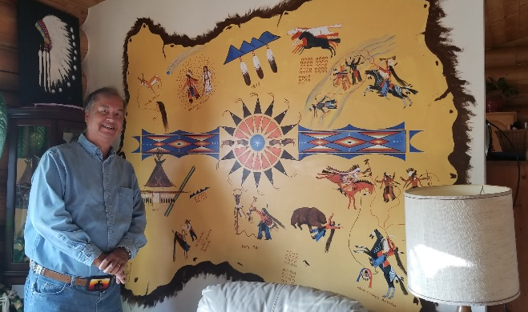
Robert De Corah

Website: www.threefeathersministry.com
Chapel Ministries
Three Feathers Ministry
584 South Greenway Drive
Port Orange, Florida 32127
E-mail Address: robertdecorah@gmail.com
1My Aunt's Great-Grandfather's Life in Pictograph

THE PRONG HORN STORY
Artist: George Shields Jr. Story as told by George Shields Sr.
Compiled by Philomayne Tucker & Ida Shields

Traditionally, Native American history, legends and family origins were passed from one generation to the next by oral story telling. In addition, pictographs (picture like symbols used in a system of writing) was used to depict historical and heroic events.
This story, told using the pictograph system, highlights the birth, deeds and demise of Prong Horn an Assiniboine Indian and Great-Grandfather of Philomayne Shields Tucker. Prong Horn, also known as Beaver Teeth, was born in Canada in the year 1829. These events and other facts and origin of Prong Horn was taken from stories of George Shields Sr. and other historical writings. In addition to the deeds portrayed here, Prong Horn accomplished many acts of bravery and as a result reached the highest status of rank in the Assiniboine Tribe and died as an honored and respected Chief of the Assiniboine Tribe.
Beginning in the upper left hand corner and reading in a clockwise direction the story goes as follows:
1829 TaTo Gana, Assiniboine for Prong Horn: his date of birth
1835 Halleys Comet (Prong Horn) age six)
1839 Prong Horn at the age of ten goes to the Sweet Grass Hills with a war party. The Three Eagle Feathers that Prong Horn was to earn in his lifetime. They were for his being first to spot the enemy, the first to attack the enemy and the first to count coup (kill the enemy). In those days a warrior earned the right for each feather in his war bonnet. At the time of Prong Horn’s death his war bonnet reached to the ground as he had accomplished many feats and deeds that were honorable of an Assiniboine warrior.
Prong Horn stole his many horses from the Sioux. Each hoof print is symbolic of one horse.
Prong Horn came upon three Crows on the Yellowstone Riover. His horse was lame and Crows being enemies were a threat so Prong Horn killed the Crows crossing the river as they would have killed him.
In Northern Canada Prong Horn took a Shield away from some Piegans. As a result Prong Horn named his son WaHA Chunga AyYaGu, Assiniboine for Took the Shields whose descendants are now known as Shields.
Prong Horn met a bear on the trail. He played dead after first painting himself all over white. When the bear put his paw on Prong Horn’s chest he let out a war hoop and the bear got scared and ran off.
Horse raiding was a way of life at this time. Prong Horn again captured horses, this time from the Crows,
Nape She, Assiniboine for None-Retreat Society. Prong Horn was a member of this society which was a very select, honored and respected society.
1851 – Wi Hamna Doken Hankta Snok Ya which in Assiniboine means TO DREAM OF THE FUTURE- How it was he knew. Prong Horn meets a trader who tells him of the coming of the white man, the killing of the buffalo and that Indians would be put on islands.
Flatheads across the mountains, Prong Horn captured horses and brought them back across the mountains.
1885- Prong Horn’s date of death. His teepee was closed up with all of his belongings and burned. In those days the Chief’s teepee was painted with pictographs of the owners deeds. Prong Horns was covered with stories. Below the teepee is Prong Horn staff with twelve eagle feathers. The green line represents the Holy Trail (Canada/US border). Prong Horn died north of the trail in Canada.
In Prong Horn’s time, the Assiniboine men were known for their long hair worn straight. Prong Horn’s hair came down to his ankles. The shirt that Prong Horn is now wearing in this story was full of holes which was symbolic of the society that he belonged to.
PERSONAL: On a visit in 2003, while I was leading a youth camp and VBS on Fort Belknap reservation my Aunt and Uncle Rhinehart & Phyllis Shield Tucker told me this story. She said she had a typewriter that George Shields Jr. wanted. He asked how much do you want? Phyllis said she would take a painting. George Shields Jr. showed up for three days painting this. He walked with crutches having had a leg amputated. He began painting standing and then leaning. My Uncle ended up building a platform for him to climb unto to finish this pictograph.
I thank my cousin Becky Tucker Andrews and Uncle Rhinehart who Pam and I just visited with in August of 2019. Growing up we would visit there on my Mom’s reservation. I would help at times drive cattle, baled hay once and mended the fence lines. My Grandmother Juanita Tucker taught me to make moccasins, do leather work and loom bead work. Her dolls are in the Smithsonian Institute. She was born 1897 and lived 102 years. She shared what it was like growing up in a teepee and the old ways. She dismissed so much of today as not being the old Indian ways.

Challenge either you, or your church or Bible study group become a partner with us?
You can also keep up on www.facebook/nativeministriesinternational
Or www.facebook/threefeathersministry
For online giving us https://nativemi.org/partner-with-nmi/
Or mail to
Chapel Ministries
c/o Rev. Robert De Corah
584 S Greenway Dr.
Port Orange, Florida 32127
Thank you so much!

P.S. please forward or post to your website or Facebook site.
https://nativeministriesinternational.growthzoneapp.com/ap/CloudFile/Download/Qra4xn4L

