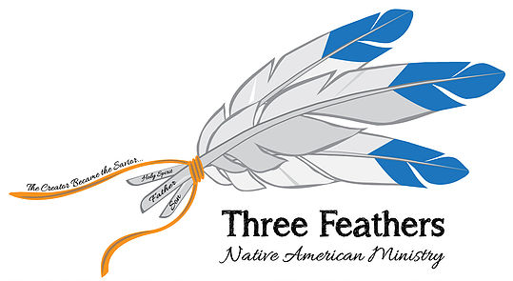
www.threefeathersministry.com robert@threefeathersministry.com Rev. Robert De Corah

Three Feathers Ministry Becomes Partners With The Center for Indian Ministries Under Oak Hill Christian College – As Guest Teacher, Conference Speaker & Representative

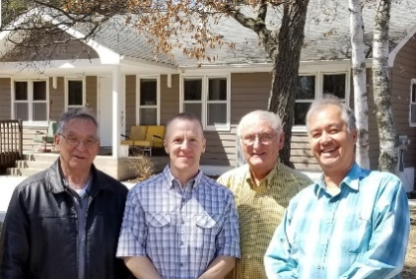
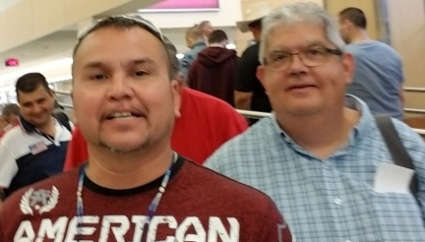
A new partnership between Three Feathers Ministry and the Center for Indian Ministries has begun this new year. Last we we partnered through their B.U.I.L.D. program training native leaders on the reservation where they are. Combined with CHIEF MINISTRIES this new program stands for Biblical United Indigenous Leadership Development. Last year I spoke on the Pine Ridge Indian Reservation and the Confederate Tribes of Collville in Washington state. I look forward to this year speaking on additional reservations and as a guest teacher at Mokahum Ministry Center in April as well as preaching at Indian Churches and visiting tribes. .
https://www.youtube.com/watch?v=dVQ3wOx98-s&feature=youtu.be Bill Haas Miller Ballard

LAUNCHING NEW WEBSITE TO TIE ALL CHRISTIAN NATIVE CHURCHES AND MINISTRIES TOGETHER
There are 7 million Native American Indians in the United States – 55 million Internationally. 567 Tribes on 326 reservations and 247 seeking recognition, Reaching these lost ones for Christ is a monumental task! The use of modern technology is the way to connect all churches, ministries and tribes.
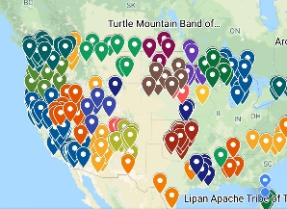
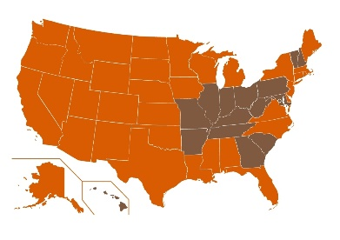
The brown states are without Federal Tribes. You can click a state and see all tribes. The Dotted Place Holder Map can be expanded to see all tribes and you can click a tribe and see information or click tribal website.

This Year is Crucial in Getting a Traveling Ministry Off the Ground Through God Called Partners in Reaching Native America Pam and I Will Travel Together
First, I want to thank every partner who made this past year possible. Thank you foremost for praying for the blessing of God. As you can see He has step by step, led the way. As we begin to travel, some months for weeks at a time it will costs a lot in gas, used RV payments, insurance etc. With our ministry Three Feathers combining with a nationally recognized ministry, C.I.M., doors for preaching, reaching and guest teach will be in abundance. This is a faith ministry. It is one where there is little income and a lot of outgo. As a couple we do not have the means to do what God has called us to. He said, “Go!” and Go we shall with your help. I believe all who make this possible will on the day of the Believer’s Judgment, will share the soul winners crown for making this possible. A minister is the one who shows up, but many, many others that are the Senders make it possible for them to go.
April is our first trip together. We have needs to be able to get everything ready and the expense of being on the road for 3 weeks. I will be speaking in two churches and teaching one week at a Native Bible School, Mokahum, and meeting with church leaders and tribal leaders in Wisconsin, Minnesota, Nebraska and Oklahoma. One of our main goals will be to begin in earnest to sign up churches and ministries and provide them a free website page to help growth. We will provide a map with individual dots to show where native churches are.
Native Ministry International Blog Site on Face Book – Preventing Ministry Burn Out 1st Blog
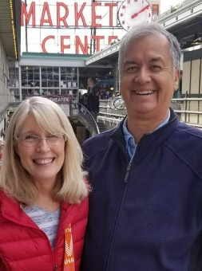
You can give on line at www.threefeathersministry.com or www.nativemi.org
Many are beginning to send gifts monthly or one time gift to
Chapel Ministries 584 S Greenway Dr Port Orange, Florida 32127
Or are setting up monthly payments through their online banking by setting up recurring payments through Chapel Ministries and the above address. The bank send a physical check to Chapel Ministry at 584 S Greenway Dr. Port Orange, Florida 32127.
If you would like to e-mail our Treasurer Vernadyne Fisher at vernadynefisher@att.net.
Please pray about having us come and share our ministry with your church perhaps if they would like to help sponsor us as their missionary to Native America. I can also FB Live with your missionary group or SS Class.
May Billy Graham’s prophesy come true.
THE NATIVE AMERICAN HAS BEEN A SLEEPING GIANT. HE IS AWAKENING. THE ORIGNIAL AMERICAN COULD BECOME THE NEXT EVANGELISTS WHO WILL HELP WIN AMERICA FOR CHRIST. Pray Revival Comes in 2019!
Rev. Robert W. De Corah Minister to the Native American Indians

