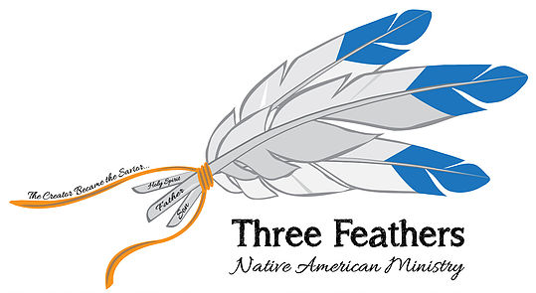

478 S. Greenway Drive Port Orange, Florida 32127

Dear Prayer Partners,

Your prayers have been answered – God has blessed the developmental stages of Three Feathers in miraculous ways!
A website is up and running that ties all Christian Native Churches and Ministries together. For the first time, 567 tribes on 326 reservations will be able to contact each other through the use of modern technology. We were told that it couldn’t be done by many programmers. God gave direction and supplied the necessary knowledge and IT HAS BEEN DONE! (See website address www.nativemi.org)
Not only does this site supply all Reservation and Church location information it also provides a teaching ministry. Many Native American Indian Pastors are trained but others self-taught. They need and want instruction in the Scriptures. They want to know how to build a church, Sunday school and youth work. Reaching the 7 million NAIs is a monumental task and it requires many, many NAI Pastors and teachers. What better way to reach these lost ones than by the witness of their own people. There are many denominations and Christian organizations that work with the NAIs, but that is not enough. Teaching NAI believers how to be Pastors, and Missionaries is a MUST!
This past year all of our time and energy has been heading up the development of this site and preparing material for the teaching ministry. We have one mission trip under our belt. Traveling from Florida to Minnesota to speak and teach taught us that – the cost is prohibitive! The cost of housing and the fast food route is not the best financially nor is it healthy.
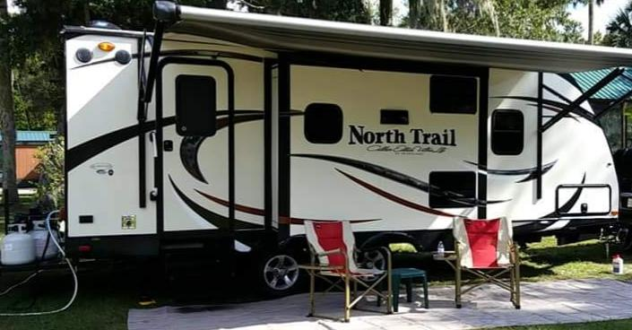
By faith, we purchased a 2014 23’ RV and a 2000 F250 7.3 deisel truck. With this
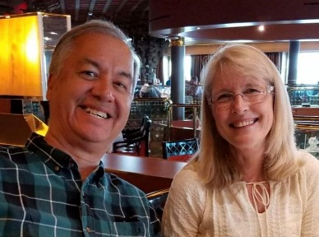
equipment Pam and I can have proper housing and meals at a reasonable cost. Keeping in mind that many Reservations are in remote areas where lodging may be non existent. Having Three Feathers become a household word is very important. We know who we are but this new ministry is unknown by the general public and the headquarters of Christian organizations and denominations.
The last week of March 2019 will take us on a three week journey. Speaking in various churches and meeting with tribal leaders on the way to Bemidji, Minnesota, where I will be teaching, for a week, at the Mokahum Ministry Center, a NAI Bible School. On our return, the plan is to meet with as many tribal leaders and church leaders, as time allows, in Nebraska and Oklahoma instructing them in the use of the website and gaining information to add to this site.
This year we have been recognized by Oak Hill Christian College and The Center for Indian Ministries as a Partner in B.U.I.L.D. (stands for Biblical United Indigenous Leadership Development) and as a guest teacher and a representative to encourage potential native leaders to receive training. I will be teaching on different reservations throughout the year.
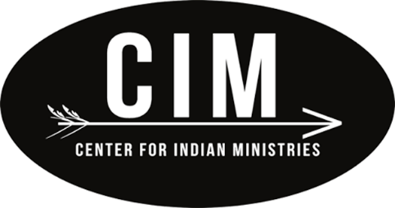

We ask:
1. Prayer for open doors in the states of Wisconsin, Minnesota, Nebraska and Oklahoma as we begin traveling the last week of March for three weeks.
2. Pray for us as we embark on this faith ministry. We are going into the Evil One’s territory. Only the power of God can protect and sustain a Christian worker in this area of ministry. Pray that God will supply physical, emotional, financial and spiritual strength.
3. Please consider devoting part of your tithes and love offerings to the building and support of Three Feathers Ministry to help travel and to pay off RV.
“Give, and it shall be given to you. A good measure, pressed down, shaken together and running over will be poured into your lap. For with the measure you use, it will be measured to you.” Luke 6:38 (NIV)
Thank you for your support! For more information go to: www.threefeathersministry.com www.robert@threefeathersministry.com.
May the Lord meet your needs and ours as we work and pray together.

Robert W. De Corah,
Missionary Evangelist to the Native American Indian

Many are beginning to become Sending Partners by giving monthly or one-time gift to: Three Feathers Ministry is accepting donations through Chapel Ministries.
Please make the check out to:
Chapel Ministries 478 S Greenway Dr Port Orange, Florida 32127
or are setting up monthly payments through their online banking as recurring payments to Chapel Ministries at the above address. Thank you and the Lord!
Chapel Ministries founded by Dr. Doug Fisher with the vision of reaching Native Americans through Native Americans. I am one of his legacies.

