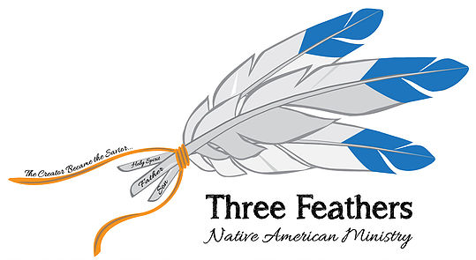

www.threefeathersministry.com robertdecorah@gmail.com Rev. Robert De Corah

A LOOK BACK ON 2019 AND EXCITING OPPORTUNITIES AHEAD IN 2020
Dear Prayer Partners,
When you first begin a ministry you pray and wonder how it will all unfold before you. Having prepared for ministry by going to Trinity Bible College, Moody Bible Institute, a B.A. degree from Carson Newman College and a Master of Divinity Degree from Southwestern Baptist Theological Seminary with 30 years as a full time pastor, you can see God’s providential collecting of life’s experiences to help now as an Evangelist to Native American Indians.
Through my ministry I have seen over the years hundreds accept Jesus Christ as their Lord and Savior and rejoice to continue to see more come to faith in Jesus. God has providentially allowed me to collect many resources to help with the discipleship and maturing of individual Christians as well as developing Church leadership.
My role through Three Feathers Ministry has been to preach and provide training both by the website and in person to deal with various aspects of ministry. I have taught future pastors this year how to preach an Expository sermon, using the internet in ministry, spiritual warfare classes learned while attending Moody Bible Institute as well as revival preaching
It was exciting being at The Gathering of Nations in Albuquerque, NM and Crow Days in Montana. It was a blessing to teach at Mokahum Bible School, return to Cherokee Baptist Church to preach 40 years later for a second time. One of the places I preached at may be the beginning of the revival Billy Graham said would come before Jesus Second Coming when God would awaken a sleeping spiritual giant the American Indian. They in turn would preach in nonnative churches in America and then throughout the world bringing the last great awakening. Twice I have gone back and seen the power of God released at All Nations Camp Meeting in Elton, Louisiana. Speaking at the Southern Baptist Convention to the Fellowship of Native American Christians was an honor. Sharing the new website connecting native nations and Christian ministries, Native Ministries International at the S. Dakota and N. Dakota Evangelism Conference as well as at the largest Native Christian camp with 2600 in attendance at Indian Falls Creek in Ada, Oklahoma.
Pam and I want to thank you for making this past year possible because I believe every soul won and every Christian restored from their backslidden condition, and every person set free from demonic oppression crowns of reward will be shared with you at the believer’s judgment seat of Christ. Jesus said as we minister not even a cup of water given in His name will be rewarded. Your generous gifts have been used by the Lord exceedingly, abundantly, above what I thought would happen.
I went for training for Four Chair Discipleship and also using Facebook ads and Google ads. I made connections with numerous ministries that can assist native ministries.
We went to the following places: Hollywood Seminole, Fl, the Menominee, WI, Grand Traverse Band of Chippewa, MI, Confederacy of Colville, WA, Coushatta, LA. Oneida, WI, Mil Lacs, MN, Lumbee, NC, Cherokee NC, Catawba, SC, Pierre SD, Citizen Band of Potawatomi, OK, Navajo, AZ, Hopi, AZ, Kaibab Band of Paiute, AZ, Cedar Band of Paiute, UT, Cedar Office of Five Bands of Paiute Nations, UT, Little Shell Tribe of Chippewa, MT, Blackfeet MT, Rocky Boys Reservation of Chippewa & Cree MT, Ft. Belknap Reservation of Assiniboine (my mother’s reservation) MT, Crow, MT, Northern Cheyenne, MT, Pine Ridge Reservation of Lakota Oglala Sioux, SD, Rosebud Reservation of Lakota Sioux, SD, Cheyenne River Sioux, SD, Lower Brule Sioux, SD, and Crow Creek Reservation, SD, American Indian Center in Minneapolis, MN, Little Earth Native Housing in Minneapolis, MN, Winnebego, NB, Omaha, NE, Tulsa, OK, spoke at FONAC at the SBC in Birmingham, AL, New Mexico SBC, SD & ND Evangelism Conference, preached twice at All Nations Camp Meeting, Elton, LA, Mokahum at Bemidji, MN, plus taught twice online in Pakistan.

We are looking forward to going to United in Christ meeting in Bemidji, MN, attending Falls Creek Indian Camp, OK and making four three week trips to visit tribal offices and minister as doors open. The Lord has opened the door to teach to over 300 pastors and missionaries in Malawi, Africa and preach a crusade in Kenya, Africa in June. I also work on the website and preach and train pastors online during the non travel time.

This past Saturday the Lord opened a door to do a Woman’s Conference in Pakistan online where several were saved and many others returned to the Lord. I have been invited to do another Conference in another part of Pakistan by the same minister next month. The conference is split in three part of the screen. I am in the left corner, the interpreter is in the right corner and the conference is in the bottom. Pray I have been invited to over a dozen nations to preach but unable to go unless airline tickets are made available. You could help sponsor a trip. Please contact me if you would like me to speak to your mission group or church using Facebook Live.

God is using the two websites I use to provide resources for ministry, Three Feathers Ministry and Native Ministries International as well as two Facebook sites by the same names. Between all my sites I have over 100,000 likes or visitors.

If you’re not already a financial partner, I’d like to challenge either you, your church or Bible study group to partner with us.
You can also keep up on www.facebook/nativeministriesinternational
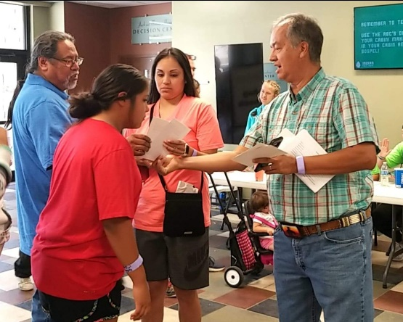
Or www.facebook/threefeathersministry
For online giving us https://nativemi.org/partner-with-nmi/
Or mail to: Chapel Ministries c/o Rev. Robert De Corah
584 S Greenway Dr. Port Orange, Florida 32127
Thank you so much!

Rev. Robert De Corah

