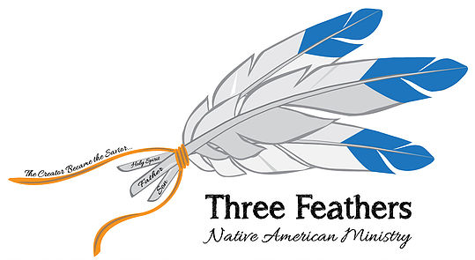

REVEREND ROBERT DE CORAH

SPIRITUAL WARFARE ON THE PINE RIDGE RESERVATION

The Lord has opened a door for me to minister on the Pine Ridge Reservation in South Dakota. I was honored to co-teach with Jim Lahn and work with Paul Straubel who leads the Center for Indian Ministries for Oak Hills Bible College in Bemidji, Minnesota. I became acquainted with Paul in July last year during the United in Christ conference sponsored CIM and Huron Claus of Chief Ministries. Jim Lahn taught on Prayer and I taught on spiritual warfare. This was the first of several classes we hope to teach this year.

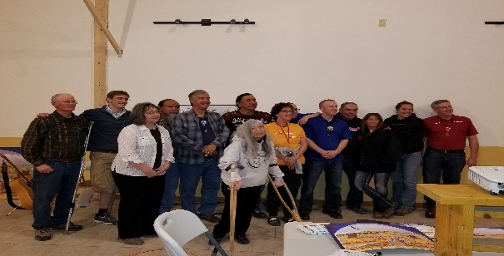
What a blessing to meet brothers and sisters in our Lord Jesus Christ among the Lakota Sioux. Pine Ridge is a spirit filled reservation but not in a positive way. The veil of darkness is slowly being lifted but the enemy will not let go without a fight. Sweat lodge ceremonies, sun dances and vision quests are common native practices. Many of our people on Pine Ridge and many other reservations are under spiritual attack by the enemy. Evil spirits are attacking them in their dreams and homes. Many see visions and demons and several have asked for prayers for them to be driven from their homes.
We had about 40 people in attendance for 4 nights. Four people accepted Christ as their personal savior and several had spiritual issues that were dealt with.

SPEAKING MAY 18TH & 20TH IN WASHINGTON STATE

GOD HAS OPEND A DOOR TO MINISTER NEAR SPOKANE WASHINGTON from Thursday May 17 to Saturday, May 19 and then speak at a church on Sunday before flying back again. Please uplift me in prayer as I speak on THE ENEMY WITHOUT. We are anticipating 120 attendees.

Schedule & Speakers

SPEAKERS
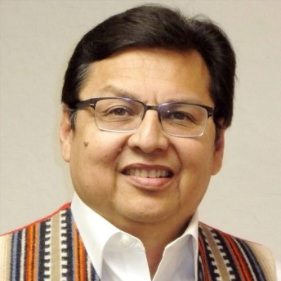Huron Claus (Kiowa/Mohawk)
Huron is president of CHIEF Inc., a ministry that works in evangelism, discipleship development, and helps among the Native peoples of the Americas. He will be speaking on “Our Creator: The Greatest Gift Giver.”
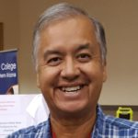Robert De Corah (Onieda/Winnegbago/Assiniboine)
Robert batted alcoholism and was involved in street gangs as a young Native boy. He shares how the Creator, Jesus, made a way to overcome this difficult life and gave him hope. He will be speaking on “Victory From The Battles We Face Without.” Robert has 40 plus years of ministry.
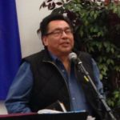Gary Quequish (Oji-Cree)
Gary is a pastor and counselor among many of Canada’s First Nations tribes. He will be sharing his powerful personal story of “Victory From the Battles We Face Within.”
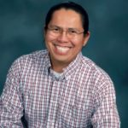Daron Butler (Navajo)
Daron is a pastor of cross-cultural ministries at Wooster Grace Brethren Church of Wooster, Ohio. He will be speaking on “Finishing Well.”
Your prayers and support for this conference is greatly appreciated. I will update you after the Washington conference to share more about my new calling to mentor and train native pastors. In conjunction with other native ministries we will soon be launching a new website that will be the first to connect Native Christian ministries and churches throughout North America and beyond.
Many Blessings,

Robert De Corah

Website: www.threefeathersministry.com
Chapel Ministries
Three Feathers Ministry
478 South Greenway Drive
Port Orange, Florida 32127
E-Mail Address: robert@threefeathersministry.com robert@nativemi.org

